Data Cleaning:

Most of the columns in the table are categorical and contains null values(missing data).

So the missing data in that particular column is replaced with most frequent occurring value.

For example for the column ‘Bullied on school property in past 12 months’ most frequent or number of times occurred value is ‘No’.

This can be checked in new worksheet by selecting that particular dimension and checking it in bar chart or pie chart.

So the ‘Null’ value in that particular column is replaced by ‘No’

Procedure:

In Tableau -> Data Source Tab -> Click on Dropdown of that particular column in the table -> and select ‘Create Calculated Field..’

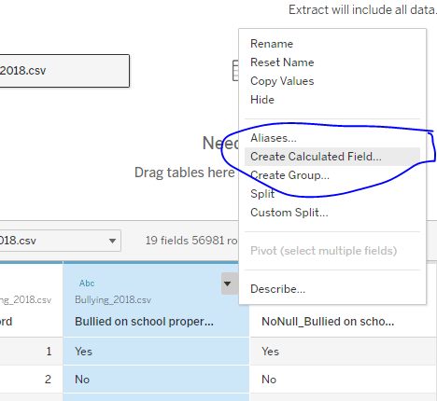

The following calculated field is created using IFNULL() function which replaces null values in the particular column with static value:

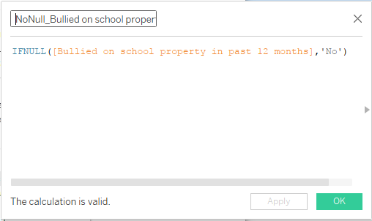

A new column would be created, we can hide the previous column and make use of new column.

The same procedure is repeated for all the remaining columns with null values and replaced with some static value.